Bahria University,

Karachi Campus



LAB EXPERIMENT NO.

**06**

LIST OF TASKS

|  |  |
| --- | --- |
| TASK NO | OBJECTIVE |
| 01 | **Implement Factory pattern for creating pages and popups(Modals, Alerts, etc.) in website for pages separate interface defined and for popups separate interface defined.** |
| 02 | **Implement factory pattern for creating Ranks/Positions of employees.** |

Submitted On:

**20-04-2022**

**Task No. 1: Implement Factory pattern for creating pages and popups (Modals, Alerts, etc.) in website for pages separate interface defined and for popups separate interface defined.**

**Solution:**

**Main:**Console.WriteLine("What do you want to look:\n1)Page \n2)Pop-up ");

int x = int.Parse(Console.ReadLine());

Console.Write("Enter that Page or Pop-up Name: ");

string type = Console.ReadLine();

switch (x) {

case 1:

Page_interface pgobj = CreateObj.get_pageObj(type);

Console.WriteLine(pgobj.get_welcome());

break;

case 2:

popup_Interface popobj = CreateObj.get_popObject(type);

Console.WriteLine(popobj.Be_carefull());

break; }

**Page:**

interface Page_interface{

string get_welcome(); }  
class Home : Page_interface {  
 public string get_welcome()|  
{ return "Welcome to Home Page";}}

class About : Page_interface{

public string get_welcome()

{

return "Welcome to About Page";}}

class Contact : Page_interface{

public string get_welcome(){

return "Welcome to Contact Page";}}

**Pop-up**

interface popup_Interface{

string Be_carefull(); }  
class Information : popup_Interface{  
 public string Be_carefull(){

return "Welcome to Information Page";}}

class Warning : popup_Interface{

public string Be_carefull(){

return "Welcome to Warning Page \n Be Alert!";}}

**CreateObj**public static Page_interface get_pageObj(string type){

Page_interface pageObj = null;

if (type.ToLower() == "home"){

pageObj = new Home();}

else if (type.ToLower() == "about"){

pageObj = new About();}

else if (type.ToLower() == "contact"){

pageObj = new Contact();}

else

return null;

return pageObj;}

public static popup_Interface get_popObject(string type) {

popup_Interface popObj = null;

if (type.ToLower() == "information") {

popObj = new Information();}

else if (type.ToLower() == "warning") {

popObj = new Warning();}

else

return null;

return popObj;

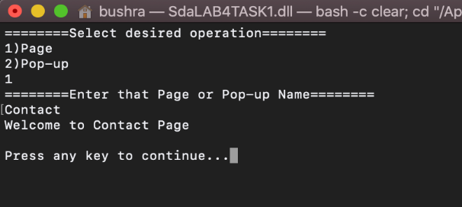**Output:**

**Task No. 2: Implement factory pattern for creating Ranks/Positions of employees.**

**Solution:  
Main**static void Main(string[] args){

IEmployee m = new DepartmentManager();

IEmployee t = new Teacher();

m.EmployeeTitle();

m.EmployeeInfo();

m.EmployeeSalary();

t.EmployeeTitle();

t.EmployeeInfo();

t.EmployeeSalary();

Console.ReadLine();}}

**Interface:**interface IEmployee{void EmployeeTitle();void EmployeeSalary();void EmployeeInfo();}

**IMPLEMENTATION:**

class Teacher : IEmployee{

public void EmployeeTitle(){

Console.WriteLine("Title: Teacher");}

public void EmployeeSalary(){

Console.WriteLine("Employee Salary is : 30000");}

public void EmployeeInfo(){

Console.WriteLine("Employee Info\nName: Adnan\nPhone No: 0212121121\naddress: abc");}}

class DepartmentManager : IEmployee{

public void EmployeeTitle(){

Console.WriteLine("Department Manager\nTitle: Manager");}

public void EmployeeSalary(){

Console.WriteLine("Employee Salary is : 200000");}

public void EmployeeInfo(){

Console.WriteLine("Employee Info\nName: abcd\nPhone No: 0212121121\naddress: xyz");}   
  
**Output:**

